**FPGA Testing**

**No Filtering:**

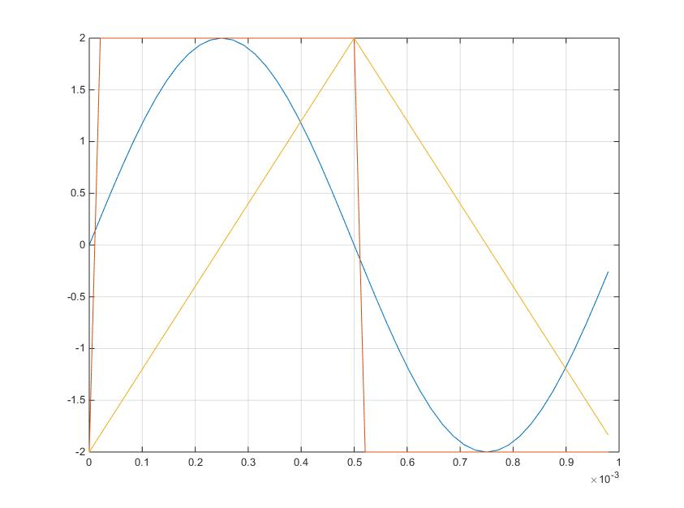

Figure 1 – Test Waveforms